

University Polytechnic of Yucatan

Student:

Manuel Oswaldo Meza Medina

Teacher:

Luis Gerardo Cámara Salinas

Class:

Advanced Programming

Career:

Embedded System

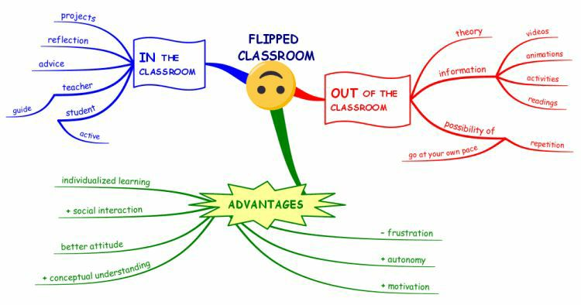Imagen:utilidad de Flipped Classrom

SDLC

The Software Development Life Cycle is a process that produces software with the highest quality and lowest cost in the shortest time possible. SDLC provides a well-structured flow of phases that help an organization to quickly produce high-quality software which is well-tested and ready for production use. It follows a plan that removes the typical pitfalls of software development projects. That plan starts by evaluating existing systems for deficiencies

Requirement’s Analysis

The team identifies, gathers, and defines current problems, requirements, requests, and customer expectations related to the software application or service. Defining software or product requirements gives teams the foresight and context needed to deliver and produce their software solutions.

Design

The team makes software design decisions regarding the architecture and make of the software solution. This can involve creating design documents, coding guidelines, and discussing the tools, practices, runtimes, or frameworks that will help the team meet the software requirement specification and goals defined in the requirements gathering phase.

Implementation

The database admin creates and imports the necessary data into the database. Programming languages are defined by requirements. Developers create the interface as per the coding guidelines and conduct unit testing.

Verification

We test for defects and deficiencies. We fix those issues until the product meets the original specifications. In short, we want to verify if the code meets the defined requirements.

Maintenance

This stage of work can involve reviewing, understanding, and monitoring network settings, infrastructure configurations, and performance of application services in production. This process can involve incident resolution or management during any issues or changes made to impact a customer or user base.

Importance

It is important to have an SDLC, as it helps to transform a project idea into a functional and fully operational structure. Also responsible for covering the technical aspects of system development, the SDLC helps with process development, change management, user experience and policies. In short, the use of the SDLC

Github Repository: https://github.com/manolomedinax/javascriptrepo